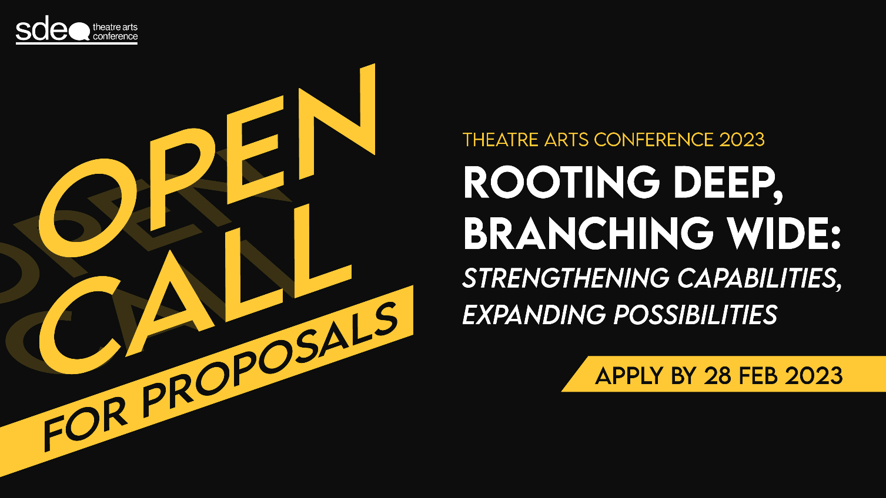
SDEA THEATRE ARTS CONFERENCE 2023
30th June to 2nd July 2022
Rooting Deep, Branching Wide:
Strengthening Practices, Expanding Possibilities

Creatives, by nature, observe, raise questions, stimulate thought, and develop agency. As we dig our roots deeper to find meaning in our current contexts, practices, and environments, we branch wide to explore new ways of doing and ways of being in an increasingly complex world. The SDEA Theatre Arts Conference 2023 aims to examine these current and evolving ways, especially within education, community, and performance.
Inviting artists, educators, practitioners and researchers to think about their work through the lenses of Practices & Pedagogies, Spaces & Places, and/or Causes & Communities, this conference will feature a range of presentations, workshops, lectures, and performances.
Rooting Deep, Branching Wide: Strengthening Practices and Expanding Possibilities, calls for proposals that respond to the theme - addressing but not limited to:

- Process-driven work on social justice, equity and diversity
- Creative work on environment, sustainability and climate change
- Creative practices as acts of care, resistance, reconnection and regeneration
- Representation and inclusion in the arts
- Creative practices in formal and nonformal sites of learning
- Unconventional interventions in conventional spaces
- Creative work in spaces and places of tension and conflict
- Creative practices that question the status-quo
- Artistic activism for social change
- Reimagination of creative pedagogies in education
- Digitalisation as an enabler for creative engagement in a hybrid world
- Artist-led responses and strategies to address significant societal matters

SDEA Theatre Arts Conference is currently accepting proposal applications. The call will close on Tuesday, 28th March 2023, 11:59pm (GMT+8). You will be notified by Friday, 28th April 2023, 11:59pm (GMT +8) if your proposal is successful.

The SDEA Theatre Arts Conference 2023 will be conducted in a hybrid format. It will take place from 30th June to 2nd July

Click here to join our mailing list to receive updates on this and other news on the SDEA
Theatre Arts Conference. For further enquiries, please reach out to conference@sdea.org.sg.

About Singapore Drama Educators Association (SDEA)

Established in 2002, the Singapore Drama Educators Association (SDEA) is an advocacy and professional development body. Its mission is to advance the profession of the drama/theatre educator and advocate for the practice and value of drama and theatre in performance, education, and community. As a not-for-profit organisation, it is managed by a committee of 6 to 9 volunteer members elected on a 2-year cycle with the support of a secretariat at Goodman Arts Centre.

SDEA is a member of the International Drama/Theatre Education Association (IDEA) and is committed to making drama/theatre and education accessible, significant and present in the lives of children and young people everywhere.

SDEA is a Registered Charity from 20 February 2020 and is a recipient of the National Arts Council’s Major Company Scheme for the period from 1 April 2022 to 31 March 2025.

The SDEA Theatre Arts Conference is an international biennial gathering for drama educators, academics, artists, and applied theatre practitioners – with a special focus on Southeast Asia. It provides a platform for presenters to share their work, research, and methodologies through practical workshops and interactive presentations. Past keynote speakers include Professor Helen Nicholson (UK), Dr Noorlinah Mohamed (SG), Koh Hui Ling (SG), Han Xuemei (SG), Ernesto Cloma (PHL), Dr Phoebe Chan (HK), Robin Pascoe (AU), and Dr Peter O’Connor (NZ).
SDEA Theatre Arts Conference 2023
Rooting Deep, Branching Wide:
Strengthening Practices, Expanding Possibilities

Proposal Submission Form
This form consists of 3 parts. Please ensure that all portions are completed.

Deadline of Submission: | Tuesday, 28th March 2023, 11:59pm (GMT+8)
Review Notification by: | Friday, 28th April 2023, 11:59pm (GMT+8)
Date of Conference: | 30th June – 2nd July
Please send the proposal to: | Attn: SDEA Conference Secretariat  Email: conference@sdea.org.sg  Title: SDEA TAC 2023 Proposal Submission (Your Name)

Part I – Applicant Information
Title:
Full Name (as NRIC/Passport):
Do capitalise the name you wish to be addressed by.
Name for Credit or Acknowledgement:
Pronouns:
Organisation:
Position:
Email:
Contact Number:
Postal Address:
Please include postal code if appropriate.
Access Requirements (if any):
SDEA will try to cater for your access requirements to the best of our ability.

Part II – Proposal Details
Title of Presentation:
Conference Strand: | - Practices & Pedagogies  - Spaces & Places  - Causes & Communities
Sub-themes:  (included, but not limiting to) | - Process-driven work on social justice, equity and diversity  - Creative work on environment, sustainability and climate change  - Creative practices as acts of care, resistance, reconnection and regeneration  - Representation and inclusion in the arts  - Creative practices in formal and nonformal sites of learning  - Unconventional interventions in conventional spaces  - Creative work in spaces and places of tension and conflict  - Creative practices that question the status-quo  - Artistic activism for social change  - Reimagination of creative pedagogies in education  - Digitalisation as an enabler for creative engagement in a hybrid world  - Artist-led responses and strategies to address significant societal matters  - Others (please specify): ______________________________________

Form of Presentation: | - Paper (20 minutes + 10 minutes discussion)  - Pecha Kucha (10 minutes)  - Performance and Dialogue (75 minutes) (including at least 15 minutes for post-show dialogue)  - Presentation (60 minutes)  - Workshop (90 minutes / 180 minutes*)  (*Please delete as necessary)
Content Abstract:

Please provide an abstract of not more than 100 words of your presentation for SDEA’s reference.

Session objectives:

Session Breakdown/Lesson Plan:
(If Applicable)

Number of Speaker(s):
Target audience:
(Include NA if for a general audience)
Minimum/Maximum number of participants:
(e.g. for a workshop to be conducted online)
Programme Accessibility Checklist: | - Access-friendly materials for people with low vision  - Use of high-contrasting colours  - Clear and larger fonts  - Carefully considered design elements  - Video captions and/or transcriptions  - Content warnings  - No sudden changes in light and sound  - Relaxed programme  - Provision of adapted activities for people with physical disabilities or sensory sensitivities (e.g. live captioning/sign  language interpretation.)  - Others: ____________________________________
Digital and Logistics Requirements:
Please let us know any needs in order to conduct the presentation digitally. (e.g. Webinar with multiple panellists, meeting with breakout rooms etc.)
If you possess a recording of a past or similar session, do send it over so that we can best understand how your presentation can be conducted digitally.

Biography of Presenter:
Please provide a brief biography (of 50 words or less) and attach presenter headshot(s) (at least 300 dpi) in email for publicity.

Part III – Declaration

I _________________________ represent *myself / my organisation in participating in the above conference.

I / My organisation warrant(s) that the materials in the proposal are my own/ the organisation's original work or materials which I/we have obtained permission to use for the conference.

I / My organisation declare(s) that all the above information is true and consent to SDEA using this information for promotional purposes.

I acknowledge and accept that the organisers may record (audio and/or video) my presentation and that the recordings or transcripts of such recordings may be published and/or used for marketing purposes.

(* Please delete as necessary)

______________________________
Signature

______________________________
Date

